EENG 385 - Electronic Devices and Circuits

BJT Curve Tracer: Deboo Integrator

Assembly Guide

# Assemble Deboo Integrator

This week, you will be soldering in the components in the Deboo Integrator area of the PCB shown in Figure 6. These components include:

1. The components associated with the DEBOO INTEGRATOR subsystems
2. The Q1 MOSFET, a 2N7000 – *POLARIZED!*
3. The STAIR test point

This week, the MOSFET Q1 is the only polarized part. You will need to bend the leads on the MOSFET to fit the staggered holes of the PCB. Just make sure the flat side of the MOSFET aligns with the flat side of the silk screen outline.

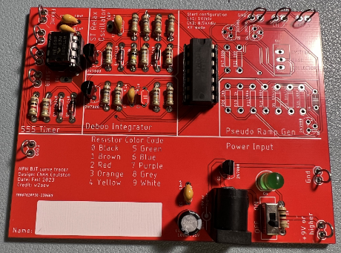

Figure : The completed Deboo integrator. Only populate one of C5 or C7 with a single 0.1uF capacitor. No way did I photoshop capacitor C7 out of the picture.

After you solder in all the components you should test and correct any problems.

# Debugging Deboo Integrator

Once you have completed assembly of your SCHMITT TRIGGER RELAXATION OSCILLIATOR subsystem, perform the following test.

1. Check the resistance between the “+9V or higher” and “Gnd” test points with the ON/OFF switch in the OFF position. You should get an overload condition on the DMM – there is essentially infinite resistance with the switch in the OFF position.
2. Check the resistance between the “+9V or higher” and “Gnd” test points with the ON/OFF switch in the ON position. This measurement jumps around and may show negative resistance. The value displayed is not meaningful. You should not get a dead short.
3. Power up the BJT curve tracer:
   * Put the ON/OFF switch in the OFF position.
   * Apply power to the board either through your AC/DC converter or using the lab power supply. If you are using the lab power supply, set the voltage to 9V and the current to 100mA.
   * Set the ON/OFF switch to the ON position.
   * The green LED should illuminate.

I would expect most problems with this subsystem to be the result of:

* Bad solder connection
* Wrong component (resistor or capacitor)

If your BJT curve tracer board fails one of the test steps in the previous section, here is some guidance on what may have happened and how to correct it.

1. If you are getting low resistance with the ON/OFF switch in the off position:
   * Make sure the ON/OFF switch is in the OFF position.
   * Check for solder bridges on the rear of your PCB.
   * Make sure you are reading the DMM correctly. The reading when the ON/OFF switch in the off position should be the same as when you hold the probes apart in air.
2. If you are getting a different resistance with the ON/OFF switch in the ON position:
   * Make sure the ON/OFF switch is in the ON position.
   * Make sure you are reading the DMM correctly. The reading when the ON/OFF switch in the ON position will jump around a lot and probably be negative.
3. If the green LED does not illuminate when power is applied and the ON/OFF switch is in the on position:
   * Test you are applying power. Put a DMM in voltage mode and check the +9V and Gnd test points.
   * Check for solder bridges on the read of the PCB.
4. If you are not getting waveforms resembling the MultiSim Live simulation:
   * Test that the board is powered up.
   * Check the oscilloscope leads are fully inserted.
   * Press the “Default Setup’” button to undo any weird configuration the last user may have left the oscilloscope in.
   * Check that solder connections by trying to wiggle each component. No visible movement should be possible.
   * Check all pins of the TLC274 are firmly engaged into the IC socket.